Lewis Palmer Baseball is Proud to partner with

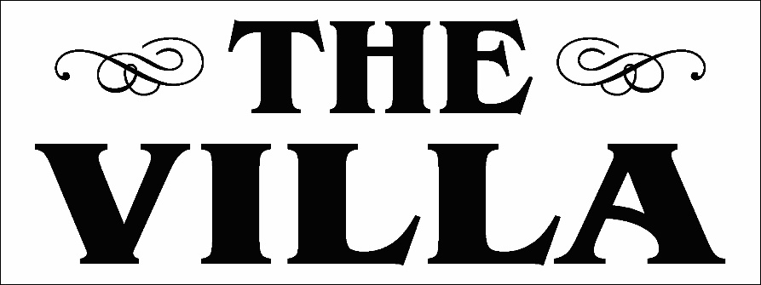

What: Eat at The Villa with this flyer and 20% of the ticket will go back to Lewis -Palmer Baseball
Where: 75 CO-105 Palmer Lake, CO 80133

When: Tuesday March 6th 4 pm until 9pm (close)

